# NeuroNER

Named-Entity Recognition (NER) focuses on extracting entities of interest locating in text, such as locations, persons, etc. NeuroNer is a NER Program based on a neural network. The neural network used is created by Franck Dernoncourt and extracted from a Python library named Neuroner. This neural network is based on a recurrent neural network called long short-term memory and contains three layers: character-enhanced token-embedding, label prediction, label sequence optimization.

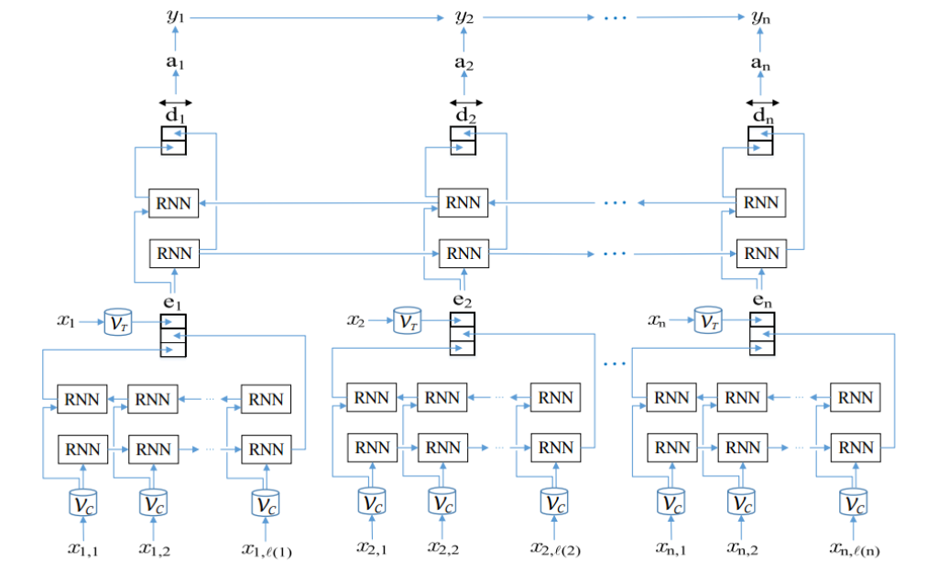

Figure 1: Diagram of the neural network used in the neuroNER

NeuroNER is chosen for the entity recognition, in this assignment, so the program can recognize entities based on statistics instead of solely on tricks and prespecified rules. The library developed by Franck Dernoncourt is used, to prevent having to spend a lot of time on developing a neural network. The library also contains multiple pretrained networks, therefore no time needs to be spent training the network. Entities are outputted in a Python dictionary using the following indexation: {'id': String, 'type': String, 'start': Integer, 'end': Integer, 'text': String }.

<http://neuroner.com/>

https://github.com/Franck-Dernoncourt/NeuroNER

Article: NeuroNER: an easy-to-use program for named-entity recognition based on neural networks